Jenkins
- Download and install JDK.
- Define JAVA_HOME to <C:\Program Files\Java\jdk1.8.0_**>. Version Used – 8u73
- Define JRE_HOME to <C:\Program Files\Java\jre1.8.0_**>.
- Point PATH to <C:\Program Files\Java\jdk1.8.0_**>\bin.
- Download and install Git from https://git-scm.com
Version Used– 2.8.3
- Download and install Eclipse IDE for Java Developers from https://eclipse.org
- Download Jenkins **.*.zip (for Windows) from https://jenkins.io
Version Used – 2.7.1
- Download ANT from http://ant.apache.org, define ANT_HOME as an environment variable (if you would be using ANT). Version Used – 1.9.7
- Download MAVEN from http://maven.apache.org. Install by entering in command prompt “mvn –v”. Define MAVEN_HOME as an environment variable. Version Used – 3.3.9
- Install Jenkins in C:\. Don’t install in C:\Program Files (x86) as it may cause a permissions issue.
- Go to localhost:8080 (Default URL of Jenkins). Enter the secret key.
- Create a new user. This user will be the “Administrator” of the CI Server.
- After login using admin credentials, create a new user like this –

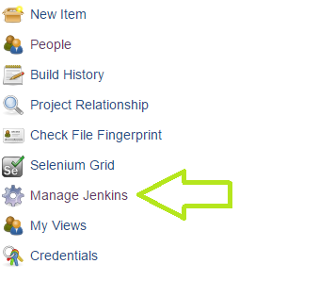

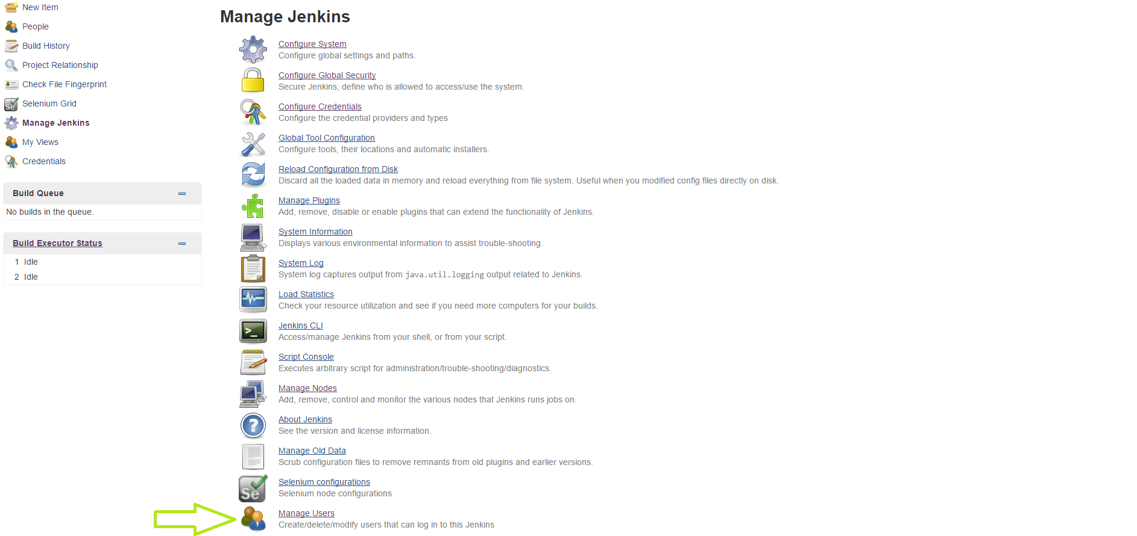

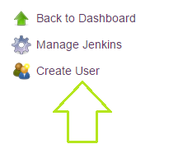
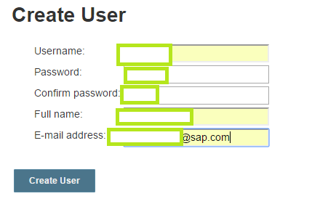

Configuring proxy in Jenkins
- Click “Manage Jenkins->Manage Plugins->Advanced”.
- Enter “proxy.wdf.sap.corp” in “Server”.
- Enter “8080” in “Port Number”.
- Don’t enter your SAP ID in “Username”, just enter your SAP password in “Password”.
- Click “Submit” and then click “Check Now”.

Note – This configuration is only needed if you are connected to SAP-Corporate. If you are connected to SAP-Internet or any other network, clear these settings. Assuming you have done everything correctly in the project and you have properly defined your POM, run your project first, on SAP Internet, as SAP-Corporate blocks POM from downloading plugins, JARs and dependencies. Also, do not select the option “Delete workspace before build starts”, as it will delete all the plugins, JARs and dependencies and download them again. When on SAP-Internet, don’t use SonarQube as it will be configured for use on SAP-Corporate.

Plugin to be installed
Click “Manage Jenkins -> Manage Plugins”. Check which are installed by default and which need to be installed. The required plugins are listed below –
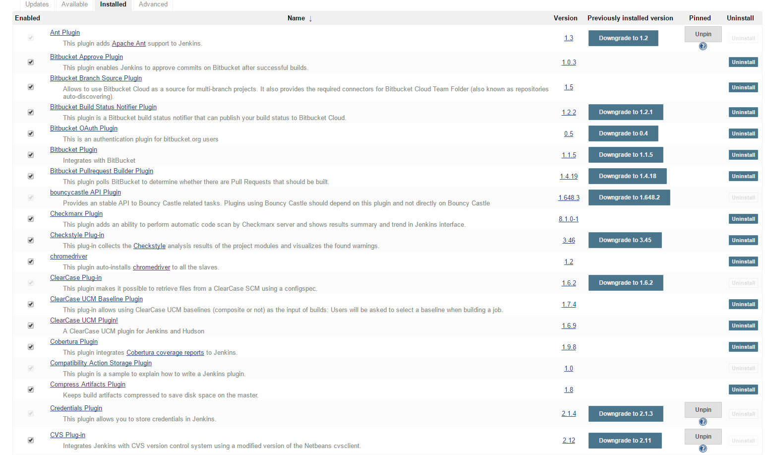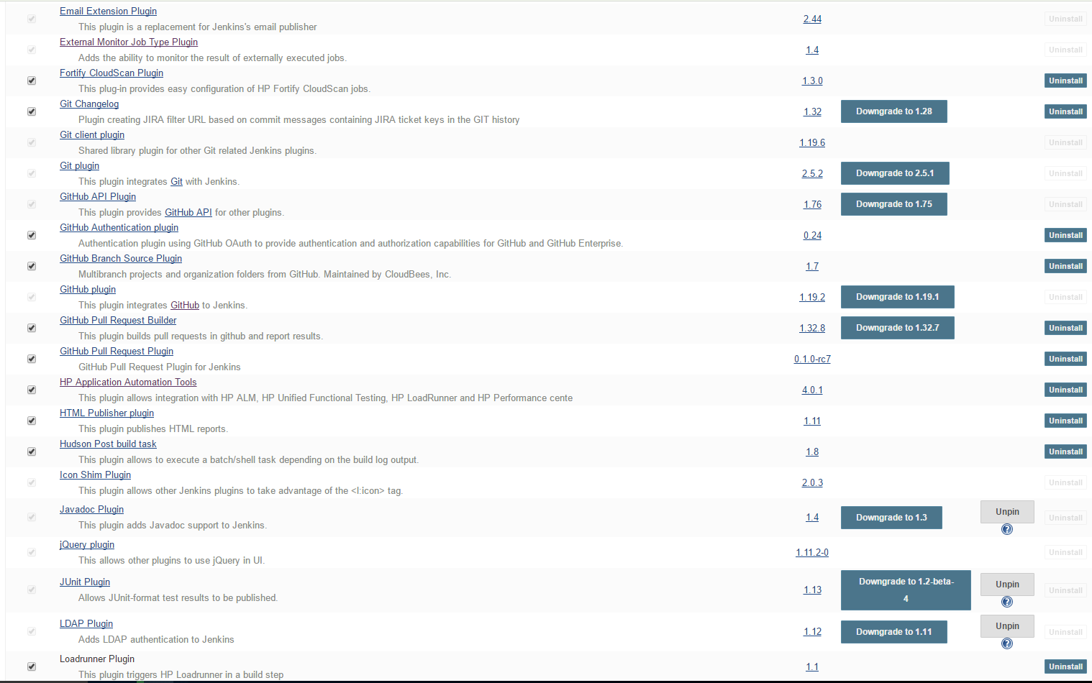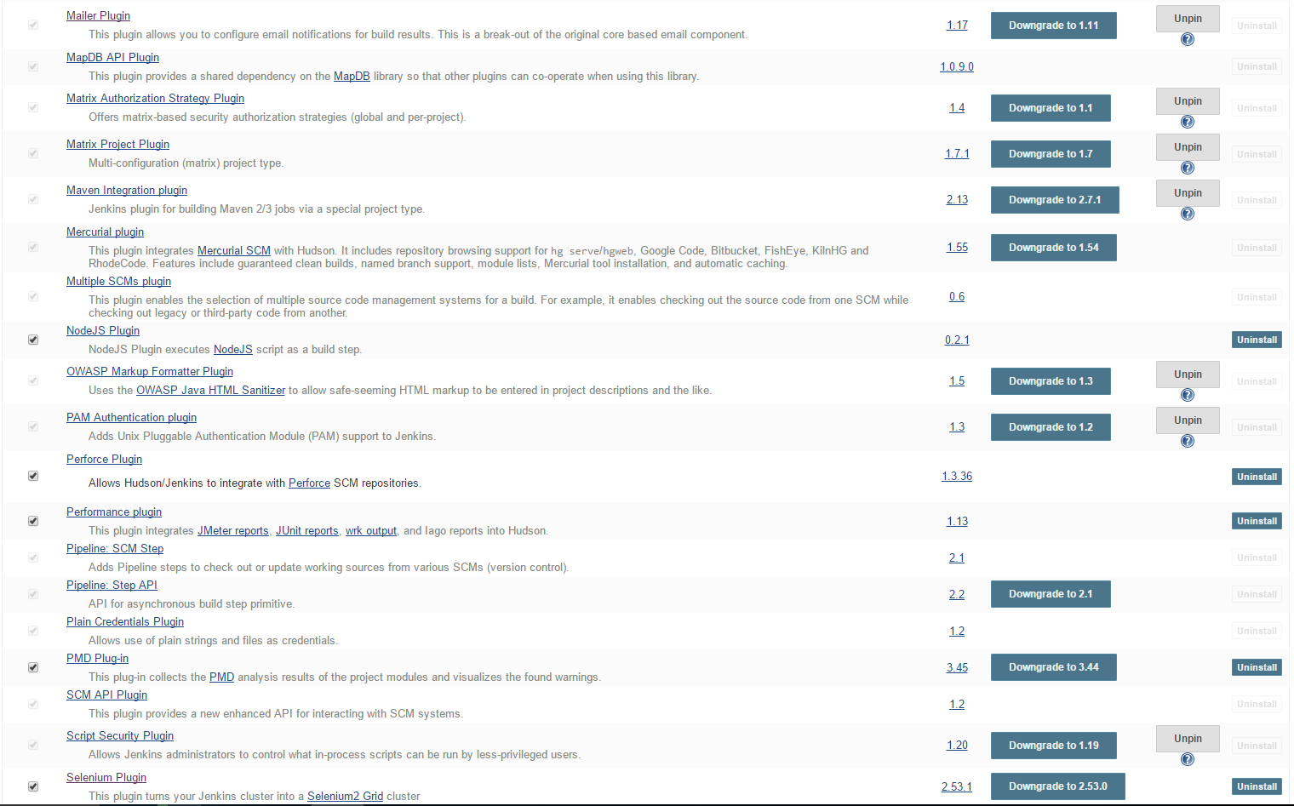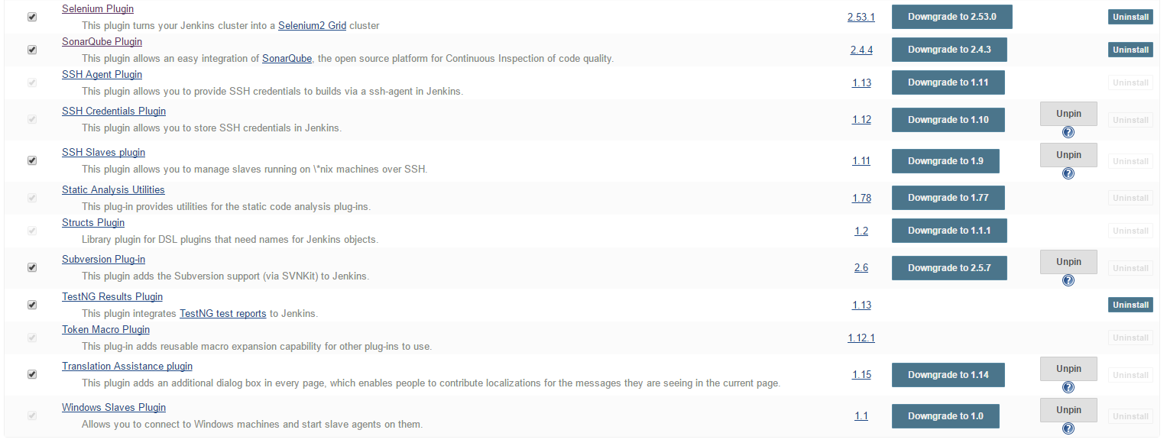

Jenkins Global Configuration
- Configure these only after all the tools are installed!
- Click “Manage Jenkins”.
- To configure JDK, Git, SonarQube Scanner, Ant, Maven & Node.js, click “Global Tool Configuration”.
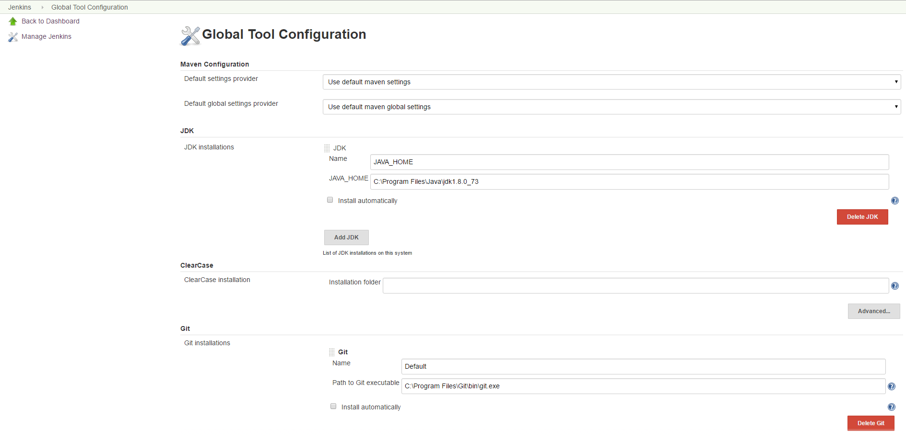
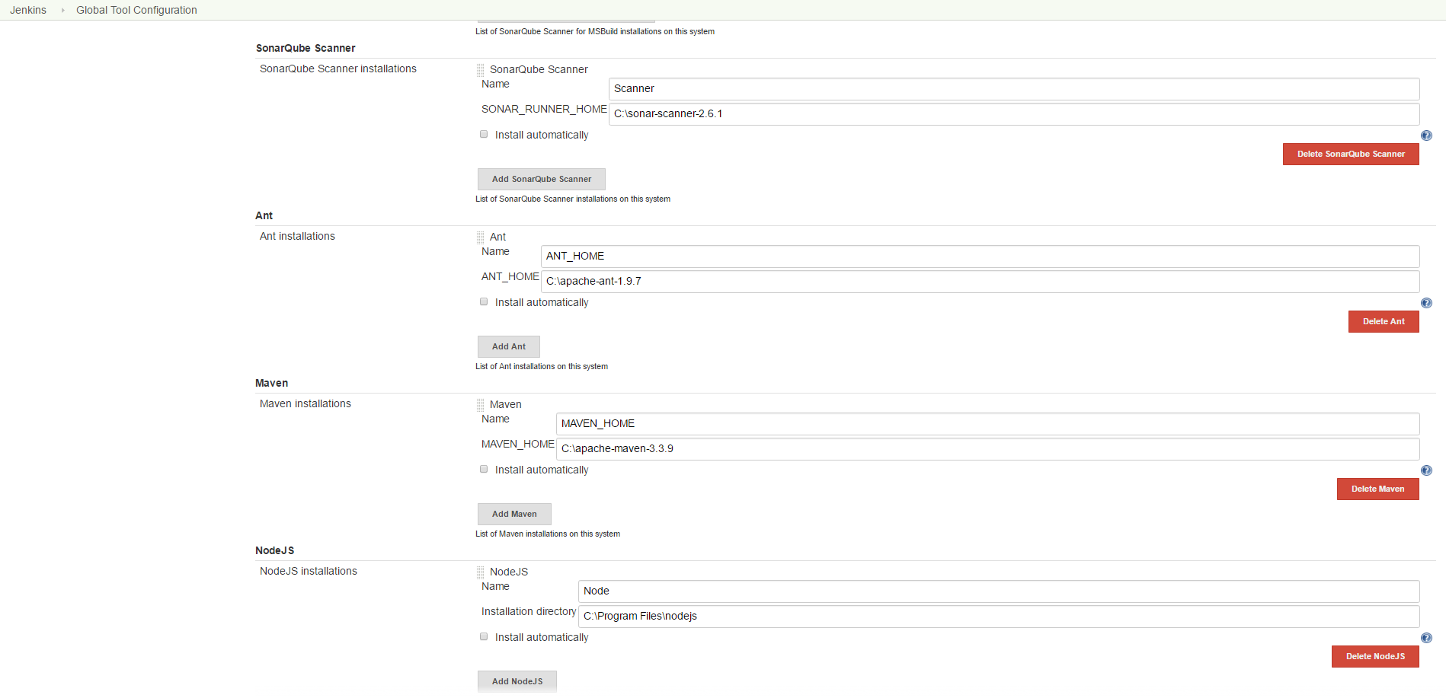
- Click “Global Settings” to manage other settings. Please note that you need to have “http://” before the IPAddress in both Jenkins URL and SonarQube Server URL because the job will fail since Jenkins would not be able to call SonarQube Server.
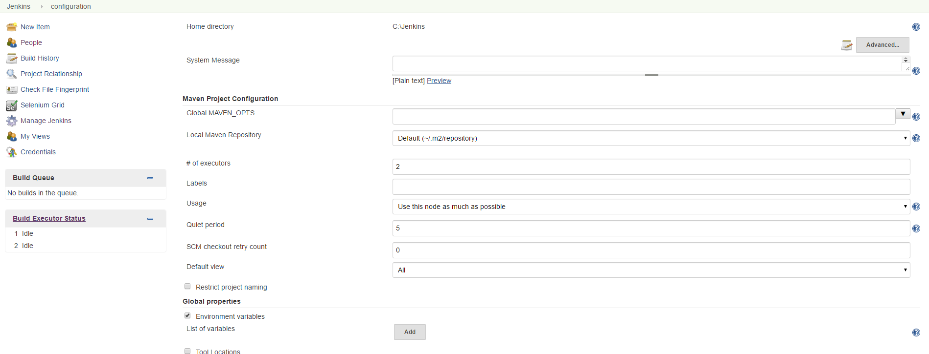
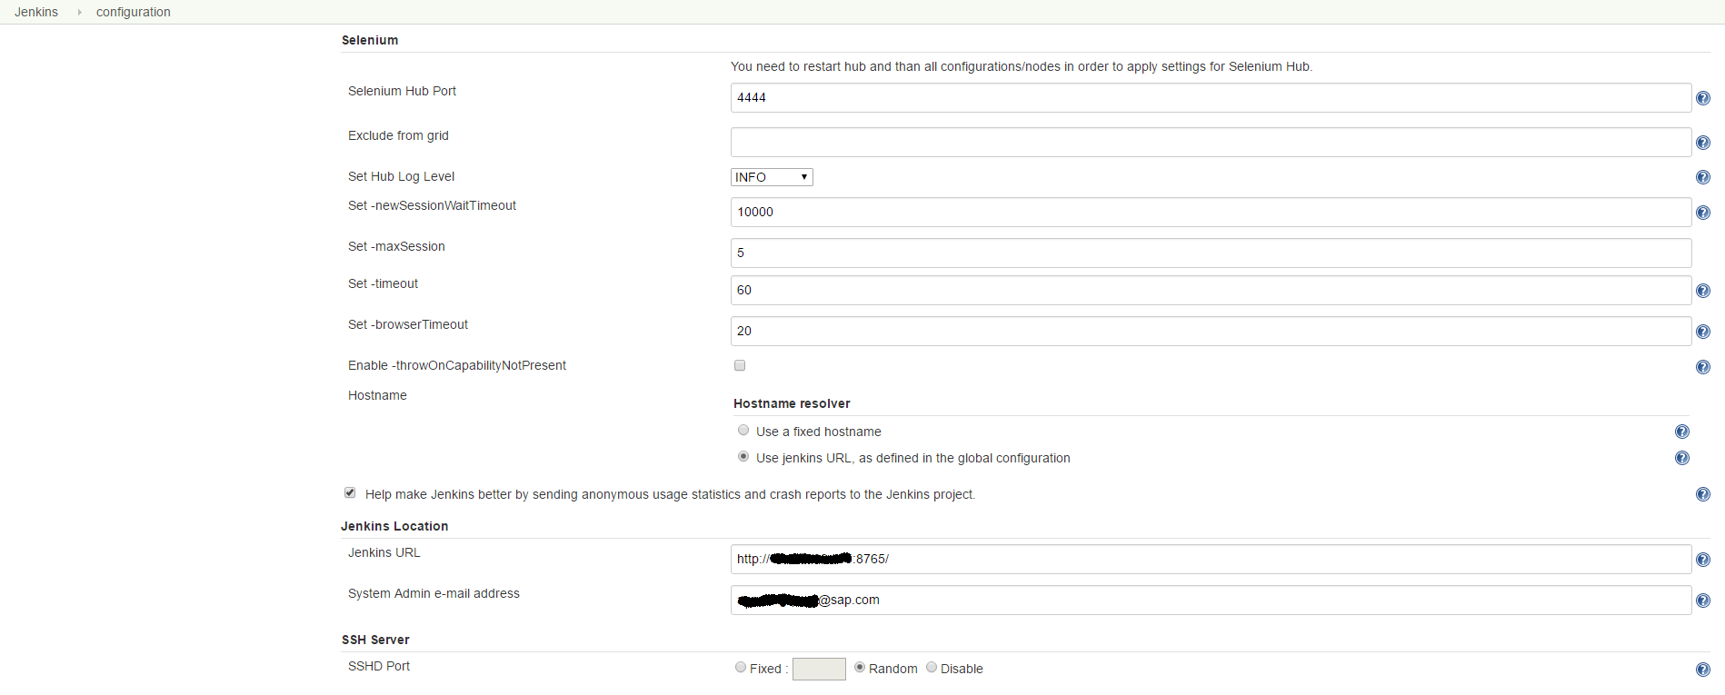
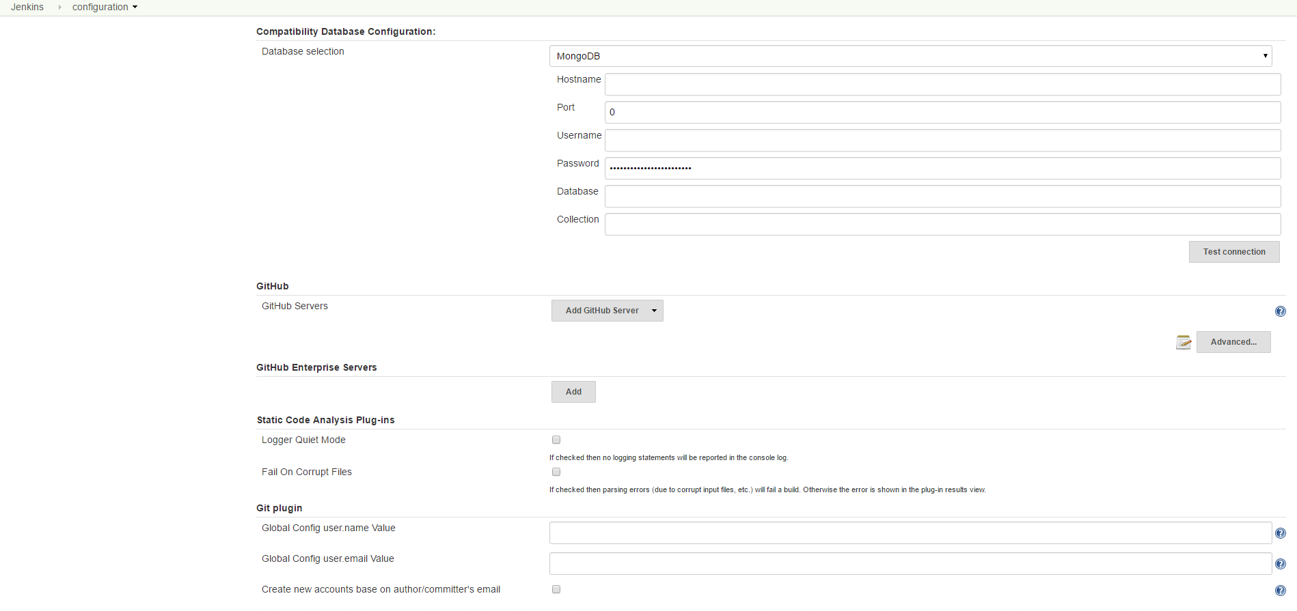
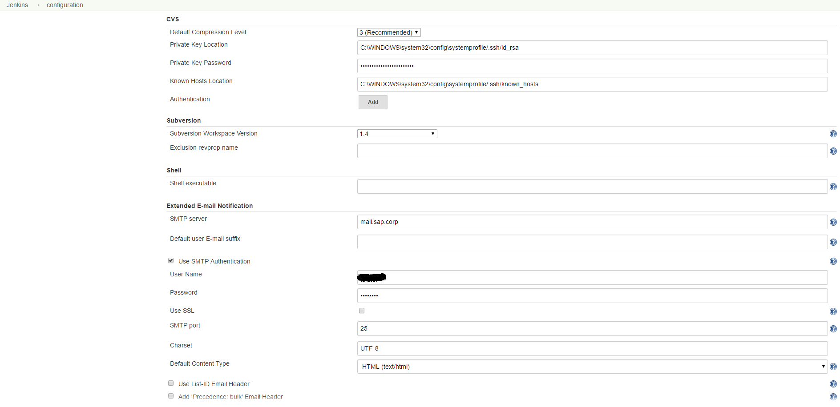
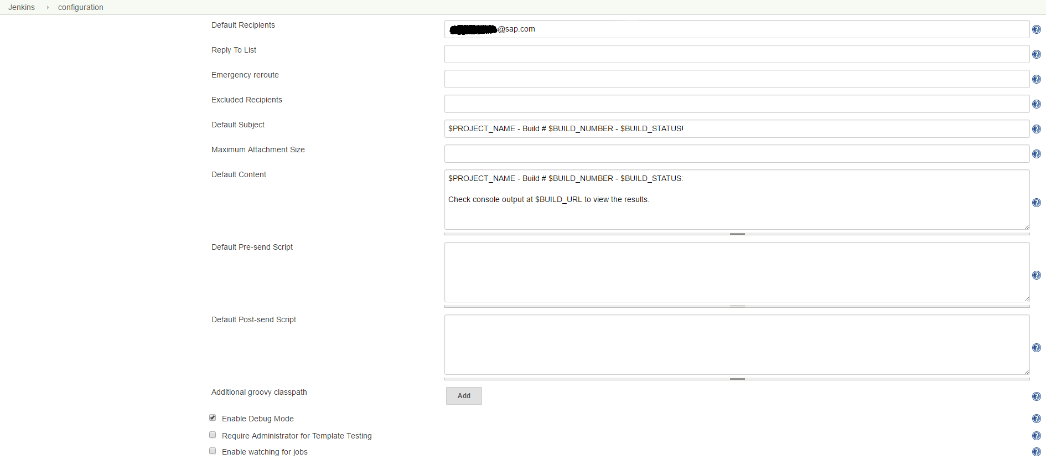
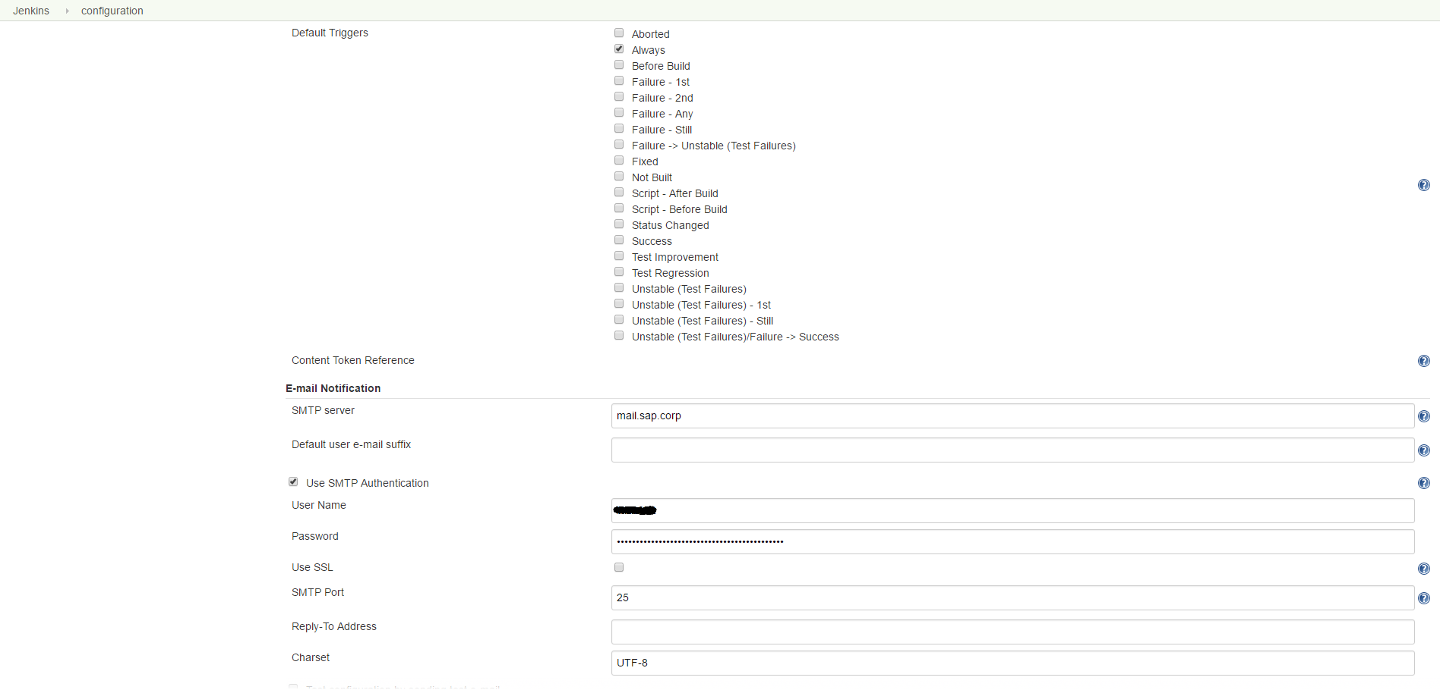
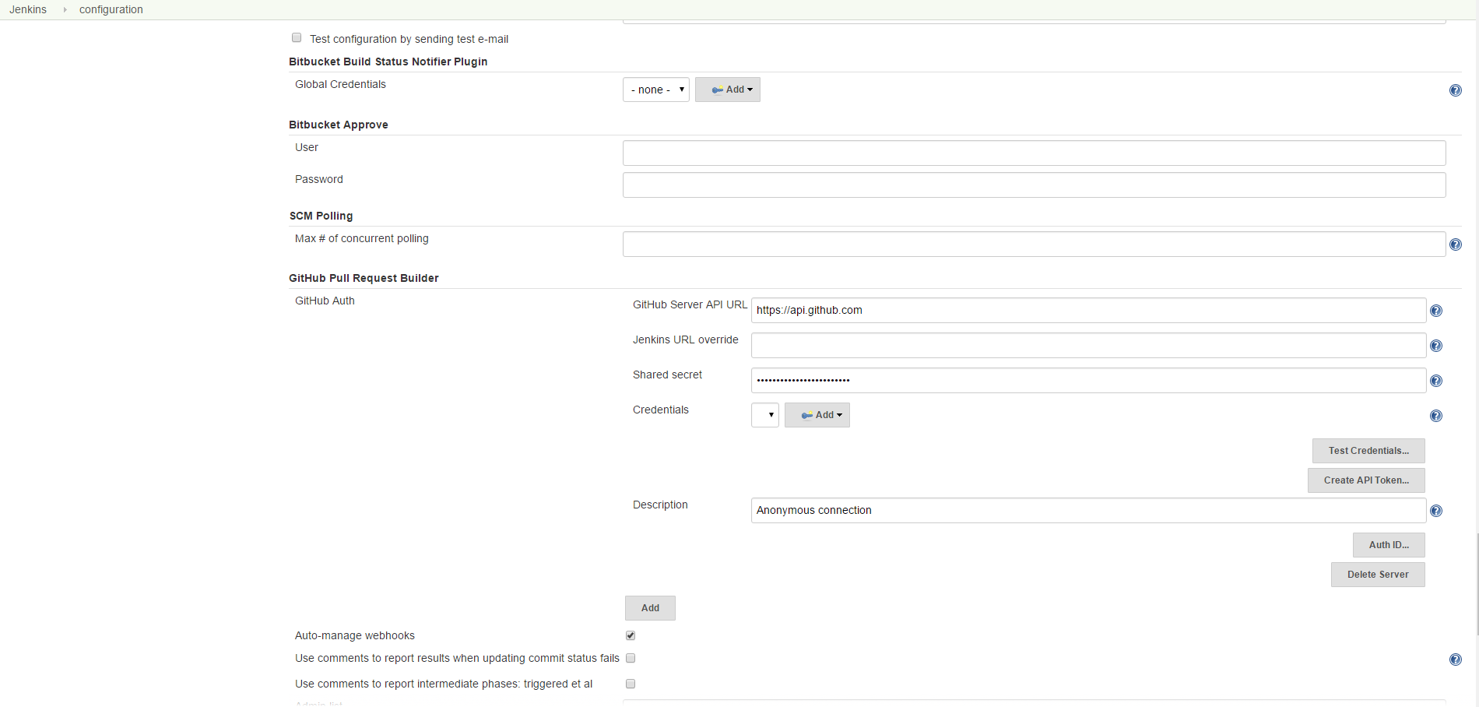
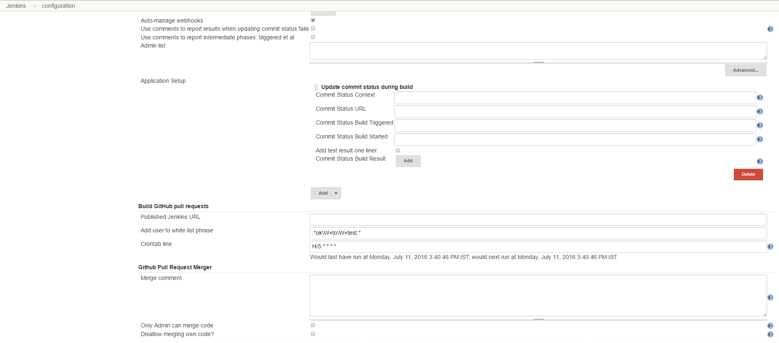

ESLint with Jenkins
- Download and install Node.js from https://nodejs.org/en/download/
Version Used – 4.4.5
- Add <Install Directory of NodeJS> and <Install Directory of NodeJS>\node_modules\npm\bin to PATH. C:\User\<SAP User ID>\AppData\Roaming\npm should also be in PATH.

Install ESLint by using commanXd “npm install –g eslint” on command prompt (admin).
- Use the command “eslint –c eslintrc.js –f checkstyle **.js > eslint.xml” in the Build Step “Execute Windows Batch Command” where ->
- –c points to the file whose config you have to use.
- “eslintrc.js” is the file which you get after running “eslint --init” at the location “C:\User\<SAP User ID>\AppData\Roaming\npm\node_modules\eslint” (though the name of the file generated is “.eslintrc.js”, remove the leading “.”). This file decides the styling format of the js file.
- -f points to the ruleset which you are supposed to use.
- Checkstyle is the ruleset which I am using.
- **.js is the name of the file(s) which you want to be analyzed.
- “>” is used for pipelining the results to a file, here I have used “eslint.xml”.
- Now, you have to publish the contents of the “eslint.xml” file, so I used “Publish Checkstyle Results” in the Post-Build step and mentioned file name as “eslint.xml”.
- Now, when you make a build, you will see that execution of build fails, here is the solution->
- Go to the “Services” app.
- Find the “Jenkins” service and right-click on it.
- Select “Properties” and go-to the “Log On” tab.
- Select “This Account” and enter your Account ID like this -> “GLOBAL\<Your SAP ID>”.
- Enter and reconfirm your SAP password.
- Click “Apply” and “OK”.
- Stop the Jenkins service and then start the service.
- Now, click “Build Now” and you will see that “Batch command” executes successfully.
- In case, the above command doesn’t run, run this command “eslint –f checkstyle > eslint.xml”.

Checkstyle, PMD, Cobertura
- Download and install Checkstyle, PMD and Code Coverage (Cobertura) plugins.
- Now in your project’s pom.xml, include plugins and dependencies required according to the format mentioned on Maven Central repository http://search.maven.org
or just search for it on Stack OverFlow or just Google it. You may find it on GitHub.
- Now, add Build Step “Invoke Top-Level Maven Targets” in your Freestyle Project and add the Goal for (separate, individual goals)->
- Checkstyle -> “checkstyle:checkstyle –e”
- PMD -> “pmd:pmd –e”
- CPD -> “pmd:cpd –e”
- Cobertura -> “cobertura:cobertura -Dcobertura.report.format=xml -e”
Here I am using “–e“ flag to print a complete stack trace in-case any error occurs and its highly recommended. Also, in advanced section of each, mention “pom.xml”.
- Publish Checkstyle, PMD, Cobertura reports in their respective Post-Build Step.
- Click “Build Now” and see the results.
- Below is the pom.xml needed for the above plugins and also include JUnit.

SonarQube with Jenkins
- Download SonarQube Server from www.sonarqube.org/downloads and unzip. Version 5.6
- Download SonarQube Scanner from www.sonarqube.org/downloads and unzip. Version – 2.6.1
- Download and install SonarQube plugin.
- Create environment variable SCANNER_RUNNER_HOME which points to <Directory of Scanner>.
- In PATH environment variable, make an entry which will point to <Directory of Scanner>\bin.
- Download MySQL Community from https://dev.mysql.com/downloads/
Version 5.7.13
- Install MySQL as Server Machine.
- Select Custom Installation.
- Install Server and Workbench only.
- Also select “Show Advanced Options”, which will give logging options. Select all logging options.
- Also install X Protocol/MySQL as a Document Store (NoSQL).
- Add <Install Directory of MySQL>\MySQL Server 5.x\bin to PATH for easy access.
- Login to the Local Instance with the password provided during installation.
- Create an empty DB schema named “sonar”.

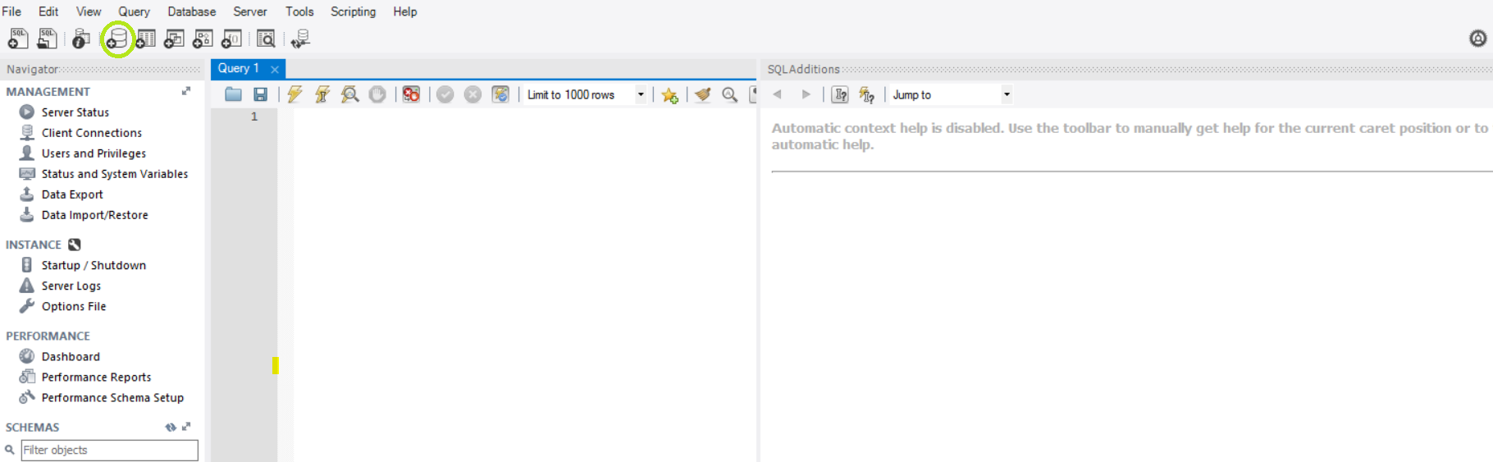

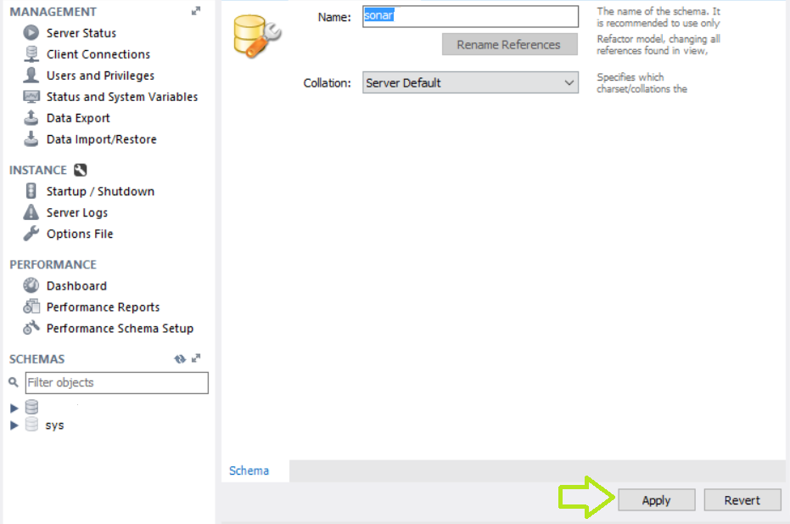

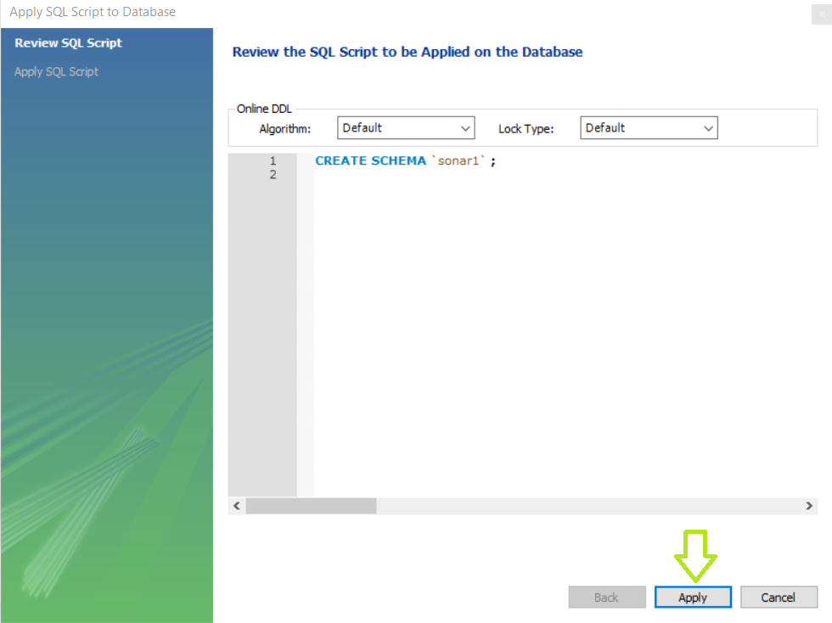

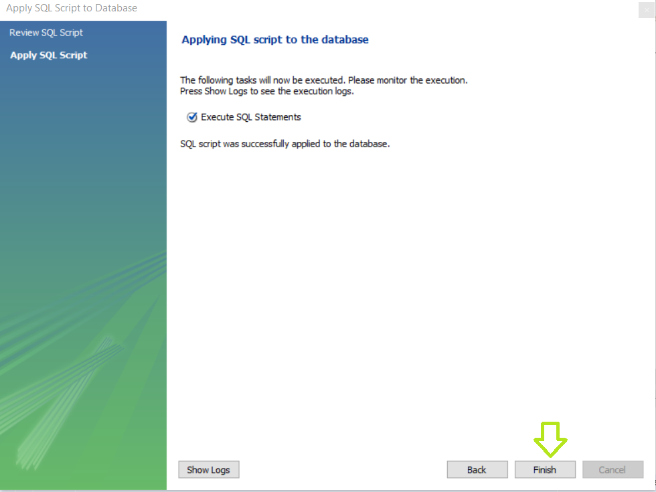

- Create a new new user with username – root and password – **** from Users and Privileges. Change “localhost” to “IPAddress”.

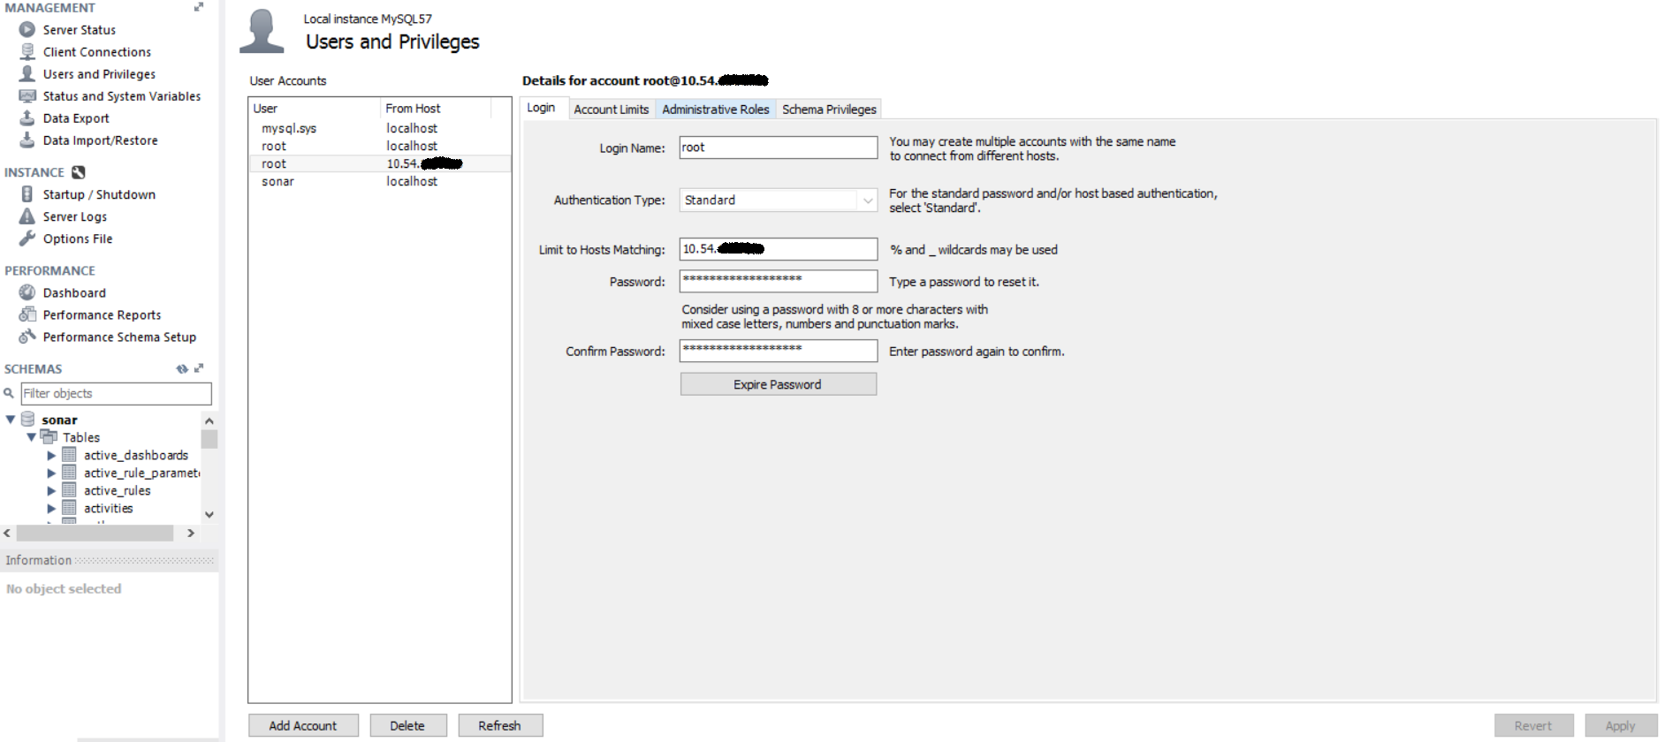

- Now, set Administrative privileges of User “root” to DBA.

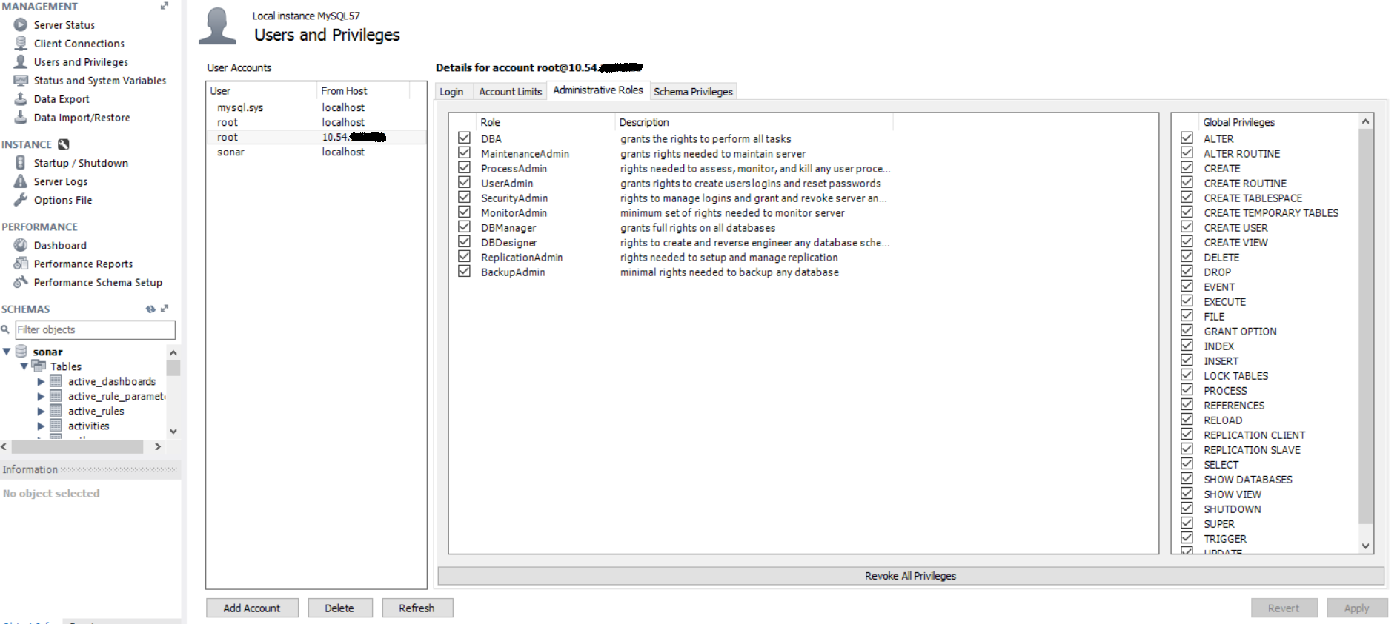

- Now, set Schema privileges of User “sonar” to access only the DB “sonar” and select all privileges, except “GRANT OPTION”.

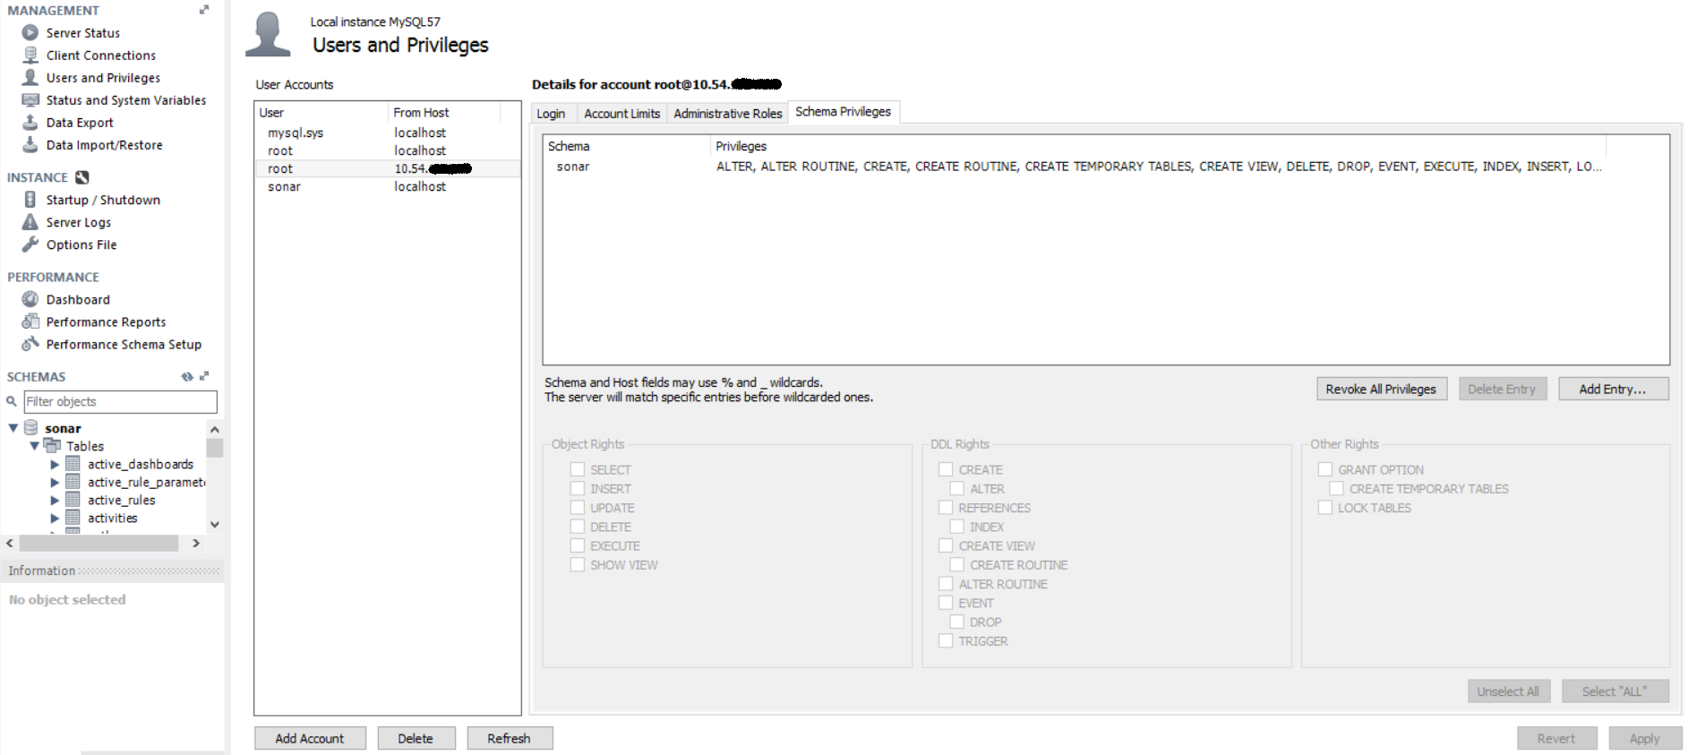

- Now create a new server instance. Give it a name and IP Address. Clear the password and enter the password you entered before. Select the default schema later.
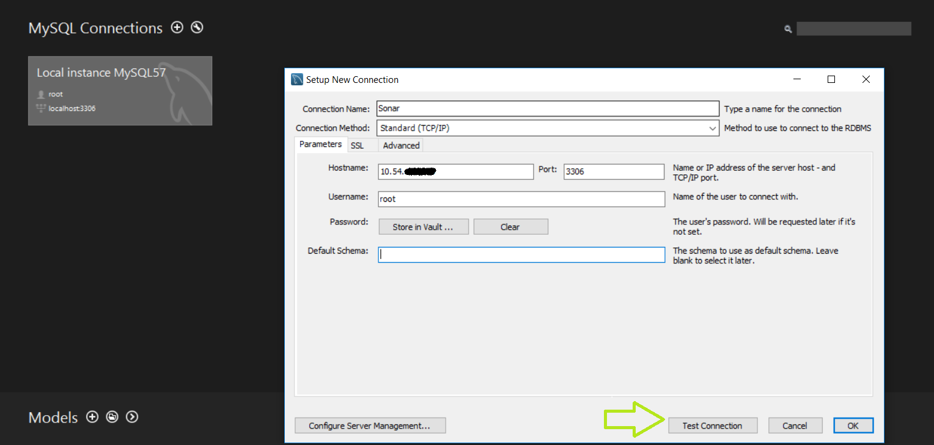

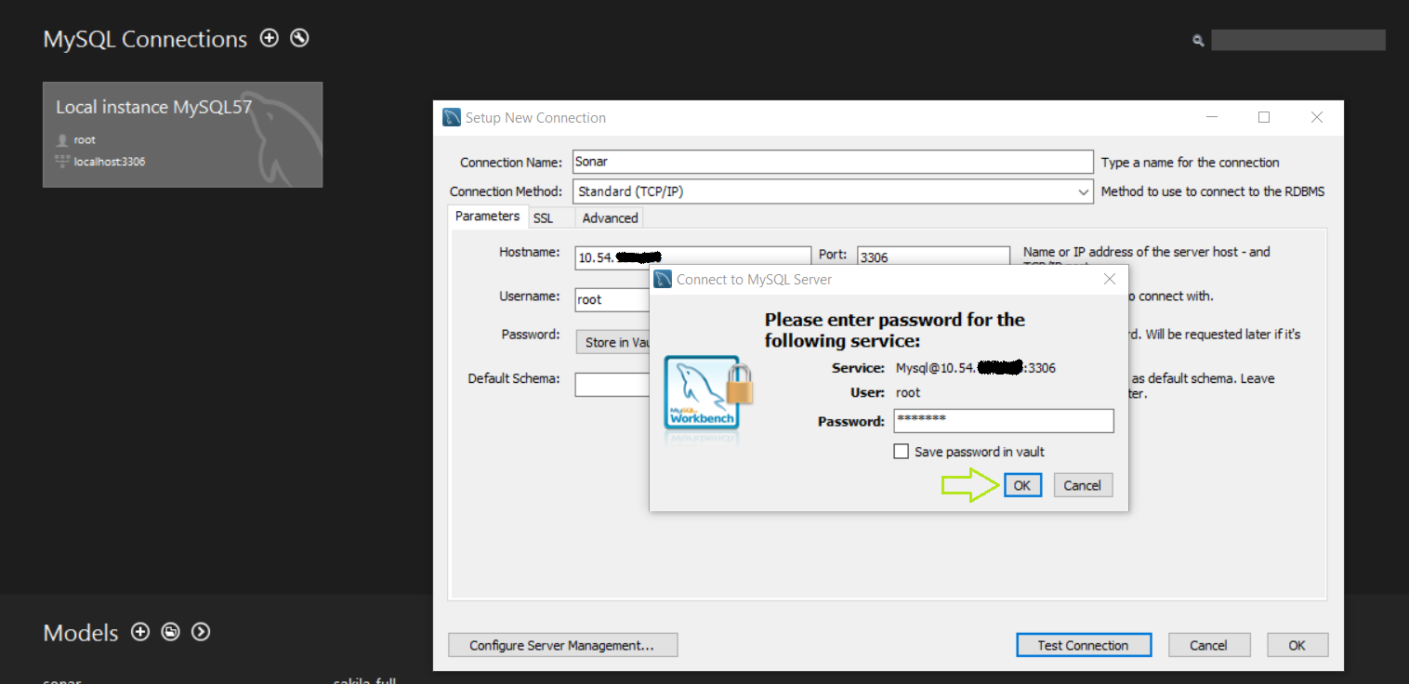
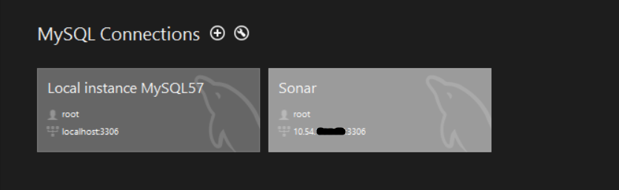

- Go to <Directory of SonarQube>\conf –

- Uncomment the following lines in “sonar-properties.xml”and set them –
sonar.jdbc.url (MySQL) (Server Instance) – Change localhost to <IPAddress>
sonar.jdbc.username=root (Server Instance)
sonar.jdbc.password=_____ (Server Instance)

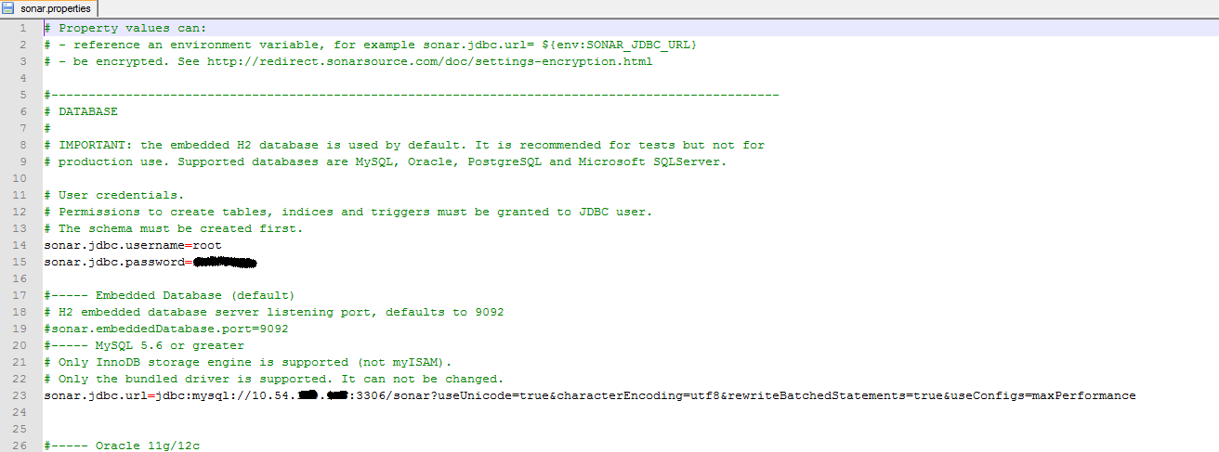

- Add the following line to “wrapper.conf” –
set.TMPDIR=<Path of SonarQube>\temp

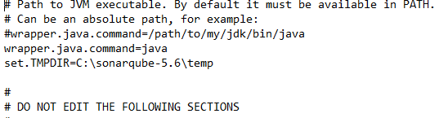

- Install the SonarQube Server (Run as Admin) at <Directory of SonarQube>\bin\Windows-x86-64\InstallNTService.
- Check if the service is running from the task manager. If not, start it.
- Run the SonarQube Server service (Run as Admin) at<Directory of SonarQube>\bin\Windows-x86-64\StartNTService.
- Use mysql –u root –p –h <IPAddress> to check DB from cmd. Use “SHOW DATABASES;” to check the list of DBs, use “USE DBNAME;” to select the DB and “SHOW TABLES;” to see its tables.
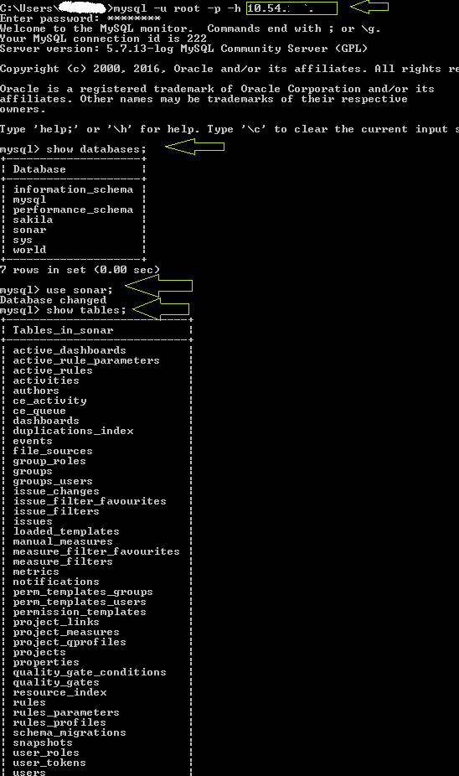

- Go to Jenkins and install SonarQube plugin and set build step of SonarQube in project.
- Make sonar-project.properties according to language in root directory of project.
- Start the Build and get the results. Location of SonarQube is <IPAddress>:9000.

Selenium Webdriver
- Download and install Selenium plugin.
- Selenium Hub has been setup at localhost:4444.
- Also download and unzip selenium-server-standalone-*.**.*.jar from http://docs.seleniumhq.org/download/
- Download ChromeDriver from here - http://chromedriver.storage.googleapis.com/index.html
- Now, create a simple Java project which invokes the webdriver and the browser (in this case, Chrome).
- Add the location of Chrome WebDriver to PATH.
- Install ChromeDriver plugin.
- There is a line in LaunchBrowser code which may be like this “http:localhost:4444/wd/hub”. If so, provide your laptop’s “IPaddress” there in place of “localhost.
- Start the node using this command “java –jar selenium-server-standalone-*.**.*.jar
-role node –hub <nodeIPaddress>:4444/grid/register -port <port no>” in the location where this JAR is located. By default, the node runs on the port number 5555, so you don’t really need the part “-port <port no>”. Don’t close the command prompt window.
- Check Selenium Grid at “localhost:4444/grid/console” to see if a node has been created.
- Invoke “Top-Level Maven Targets” in the Build Step in your Freestyle Project and enter Goal as “test –e”.
- Click “Build Now” and see that the browser page you wished to see in the browser window start and close automatically.

Postman
- Install “postman” by using command “npm install –g newman” on command prompt (admin).
- Get a public postman collections JSON file.
- Use the command “newman -c *.json -H *.html” in the Build Step “Execute Windows Batch Command” where –H points to the HTML file where test results should be written or else, use “-o” instead of “-H” to use other file format.
- Click “Build Now” and see the report published in the file.

QTP/UFT
- Ensure that your laptop is connected to SAP-Corporate.
- Download and install QTP/UFT.
- Create a QTP script and save it.
- Launch QTP. Select Tools-> Options->Run Sessions-> Configure the results to be saved as .html.
- Create a simple VB script which launches QTP, run the test and save the results in a specified location. Ensure that it works while running the script on command prompt.
- Create a new job in Jenkins.
- Use the command “CScript “<Path of VBScript>.vbs” “, which will launch QTP, run the test and close it after execution.
- If you are making more than 1 build, use “Execute Windows Batch Command” to move the existing .html files to another folder and save the latest report to original folder so that while publishing the HTML Report, there are no issues. The command is “move “<Location of .html files>" "<New Location>" “. Now the “CScript” command should follow after the “move” command.

Creating .zip using Hudson Post-Build Task Plugin
- Install Post-Build task “Add Hudson Post-Build Task” plugin.
- Select Logical Operation “OR”.
- In the Script box, enter the command “jar –cMf *.zip .”
Here, * is the name of the zip we want to create. “.” Is used to address the parent of the folder/location where the job is. So, whenever this command is run, it will create a ZIP of the workspace. “jar” is used because we are using Java to run this command. Use “jar –cMf” on command prompt first for information on the flags.

